**Lab 3 – Blackbody and Stellar Spectra**

Kevin Lehr, Zach Burnett

Department of Astronomy, University of Maryland, College Park

Email: [klehr43@](mailto:klehr43@gmail.com)umd.edu    ||    Phone: 443-472-5321

ASTR121 0101 – March 3rd

1. **Abstract**

**Spectral types of stars approximate their blackbody curves in accordance with Planck’s Law. We classified normalized spectral data over an arbitrary wavelength range by analyzing sum of squares of residual differences in normalized intensity to find the best fit for five unknown stellar spectra.**

1. **Introduction**

Light we receive from stars tells us a great deal about their nature. By analyzing stellar spectra, astronomers can determine a wide variety of stellar characteristics such as chemical composition, radial velocity, and surface temperature. Because of how much information we can extract from them, a great deal of work has gone into studying, analyzing, and classifying stellar spectra. One method of organizing stellar spectra is the use of spectral types, groups of spectra with similar characteristics. These classes are further divided into spectral types.

It turns out that there is a direct relationship between the shape of a star’s spectrum and its surface temperature. (Because of this, temperature and spectral type are equivalent representations of the x-axis on Hertzsprung-Russell diagrams.) This is because the overall shape of a star’s spectrum is defined by the Planck function:

$$I\left(λ,T\right)=\frac{2hc^{2}}{λ^{5}\left(e^{\frac{hc}{λk_{B}T}}-1\right)}$$

where intensity $I$ in irradiance per meter per steradian is calculated given lambda (wavelength) $λ$ in meters and temperature $T$ in Kelvins, and Planck’s constant $h$, Boltzmann’s constant $k_{B}$, and the speed of light $c$ are given below:

$$h=6.626*{10}^{-34}\left[{m^{2}*kg}/s\right]$$

$$k_{B}=1.381*{10}^{-23}\left[J/K\right]$$

$$c=299792458\left[m/s\right]$$

This function, however, is only an approximation of real stellar spectra. Stars are not perfect blackbodies. Light leaving the star shows absorption lines from stellar atmosphere and elemental composition.

In the first part of this lab, we wrote a function to return an ideal blackbody intensity curve for a given temperature and set of wavelengths, used that function to plot three spectral curves, and compared an ideal B0 curve to given B0 data. In the second part, we try to classify five unknown spectra by analyzing smallest sum of square residuals between the unknown spectral data and the known spectral standards.

1. **Methodology**

In the first part of the lab, we plotted blackbody curves for a theoretical M0 star, the Sun, and an A0 star, of temperatures 3750 K, 5800 K, and 9600 K respectively. To create this plot, we applied the Planck function over the space of wavelengths. The three curves are shown in Figure 1. We then compared a B0 star’s real spectrum to a theoretical spectrum based on Planck’s law, shown in Figure 2.

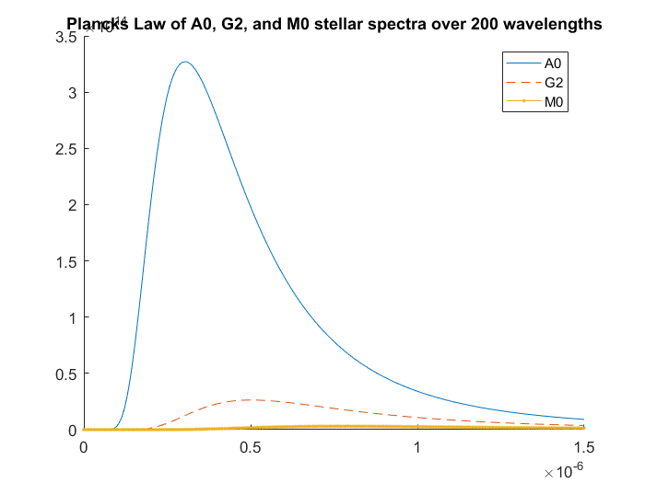

Figure 1: Blackbody Curves of M0 star, the Sun, and A0 star

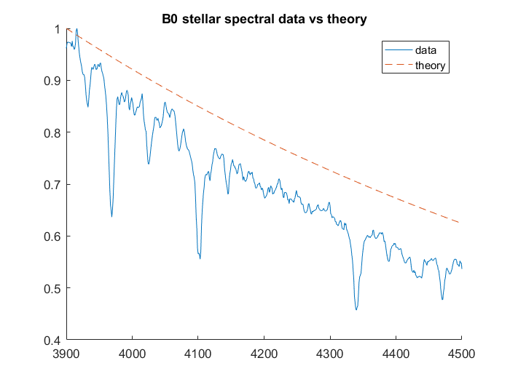

Figure 2: Theoretical and Observed Spectra for a B0 Star

In the second part of the lab, we used a set of known spectral standards to classify five unknown stars. To do this, we first analyzed the spectra and their closest matches visually. The spectra of Unknown 1 and its two closest standards, A1 and O5, are shown in Figure 3. After narrowing it down to two standards, we determined which of the two was a better match by analyzing the residuals, as described in Section 3.

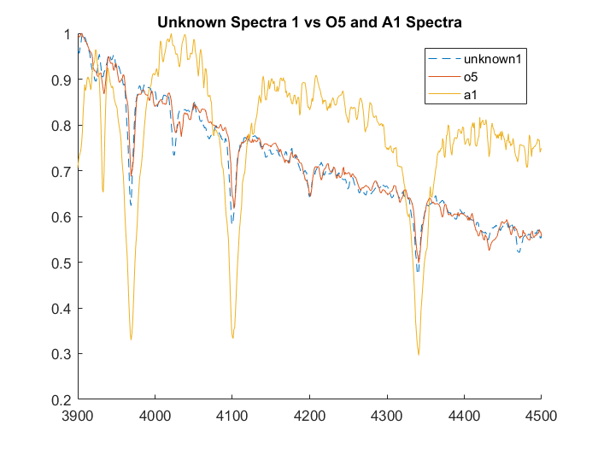

Figure 3: Spectra of Unknown 1, A1, and O5

1. **Analysis**

To determine which of two standards better modeled any given unknown star, we compared their residuals and their sums of squares. To find the residuals of an unknown spectra and a standard, we calculated the overall residuals as the difference between known and unknown data per wavelength, then minimized the sum of squares to find the best match. The residuals of Unknown 1 and its two closest standards, [*standard x and standard y*], are shown in Figure 4.

Figure 4: Residual of Unknown 1 and [*Standard x and y*]

To quantify how well a standard fit an unknown spectrum, we found the sum of squared residuals per series. The sum of squares for the potential standards for unknown one were [*report values for the two standards*]. Based on these values, we identified Unknown 1 as being closest to [*standard*]. The classifications for the remaining four stars are given below in Table 1.

|  |  |  |  |  |
| --- | --- | --- | --- | --- |
| Unknown Star | Closest Spectral Type | Sum of Squares | Second Closest Spectral Type | Sum of Squares |
| 1 |  |  |  |  |
| 2 |  |  |  |  |
| 3 |  |  |  |  |
| 4 |  |  |  |  |
| 5 |  |  |  |  |

Table 1: Results of spectral classification for five unknowns

1. **Discussion**

Qualitative analysis of the spectra proved to be more time consuming and less accurate in the long run than a quantitative minimization of the sum of squares of residual differences.